Inexpensive Contesting Headset by KG7P

Ok, so I’m cheap, it goes against the grain for me to pay for something I should be able to build. Let me explain. I like contesting, whether HF, VHF or whatever. Now that I’ve become used to using a logging program, I found it was not convenient to use the hand mike that came with my IC706. After scanning the ads in QST and CQ, and checking out E-Bay, I came to the conclusion that a mike/headset was too expensive. Reading a back issue of QST I found an adapter to use with psk31. It allowed you to use different mikes. The problem I had with this was the other things that were in the box. After all, I only needed to hook the mike, headphones and a key switch, not all the connections for a computer hook up.

I had a Plantronics headset with mike in the junk box. (you do have a junk box?). I had picked it up at the goodwill one afternoon, price $1. this was a telephone type. There was also a foot switch from an old sewing machine. No idea where the switch came from. Gathering up some plugs and jacks, I got out the mike diagrams in the owners manual. After looking over the diagram, I determined which pins were used for the mike and xmit/rcv. A quick test with a battery to find which of the four pins on the headset cable were for the earphones and the other two had to be the mike. Since Icom uses a computer type connector (rj45) to connect the mike to the radio, I simply cut a 1 foot length of cat 5 cable with connector from an old network cable I had, again, out of the junk box. I didn’t want to cut the connector off the headset cable because I had no idea what the quality of wire in the cable was. Some of the cheaper headsets have wire that is almost un-solderable.

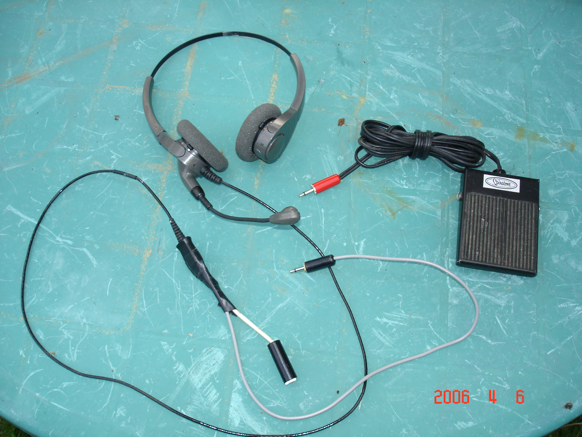
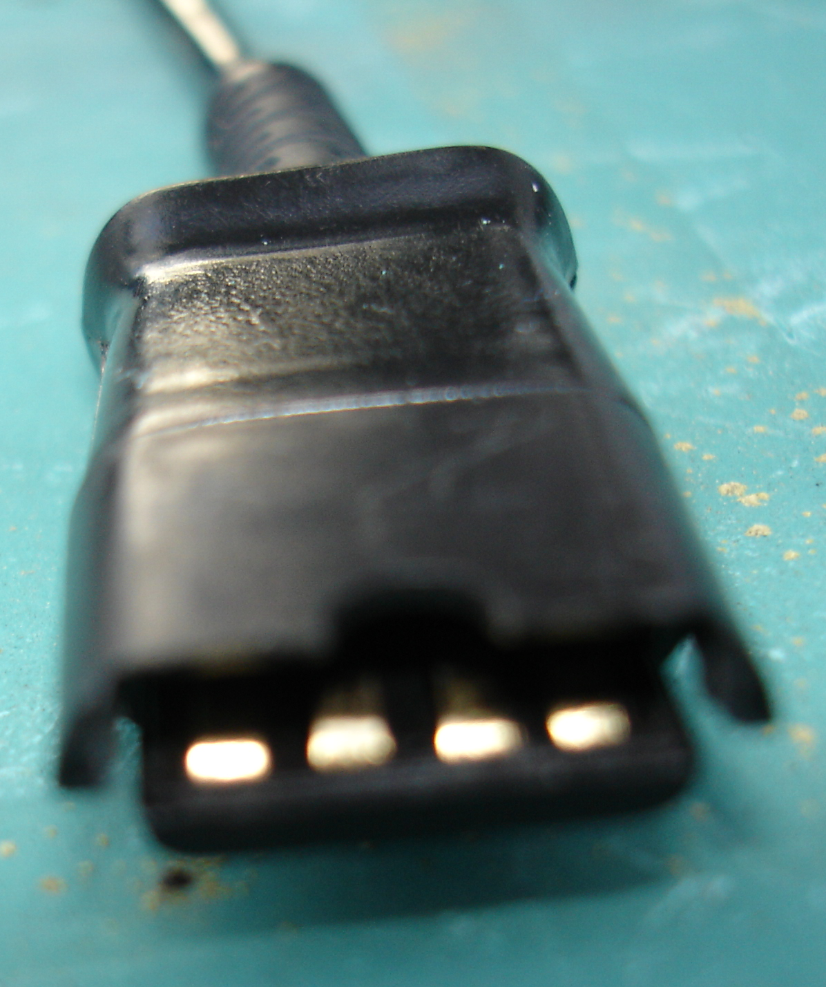
Soldering on to the flat pc connector was as simple as cutting away some of the plastic cover and tinning the runs. I soldered a short piece of wire to each of the four flat runs. I attached a plug to the mike runs and a socket to the headphones runs. No reason why either was used in the position it was used except that I was going to try to use this same headset on a Yaesu radio that used a different connector for the mike. The connections could be hard wired just as easily. The xmit/rcv was done by soldering a socket to the leads of the cat5 cable that went to the switching circuit in the radio. Then I soldered a matching plug on the end of the wire from the footswitch. To my way of thinking this use of a socket on the radio side of the switching circuit was important. I had shorted the bare wires from the radio to test the switching circuit. As a firm believer in Murphy and especially the second corollary to his law (That which positively cannot happen, WILL, at the worst possible time), I knew that somehow a plug would get shorted and the radio left in transmit for an extended time.

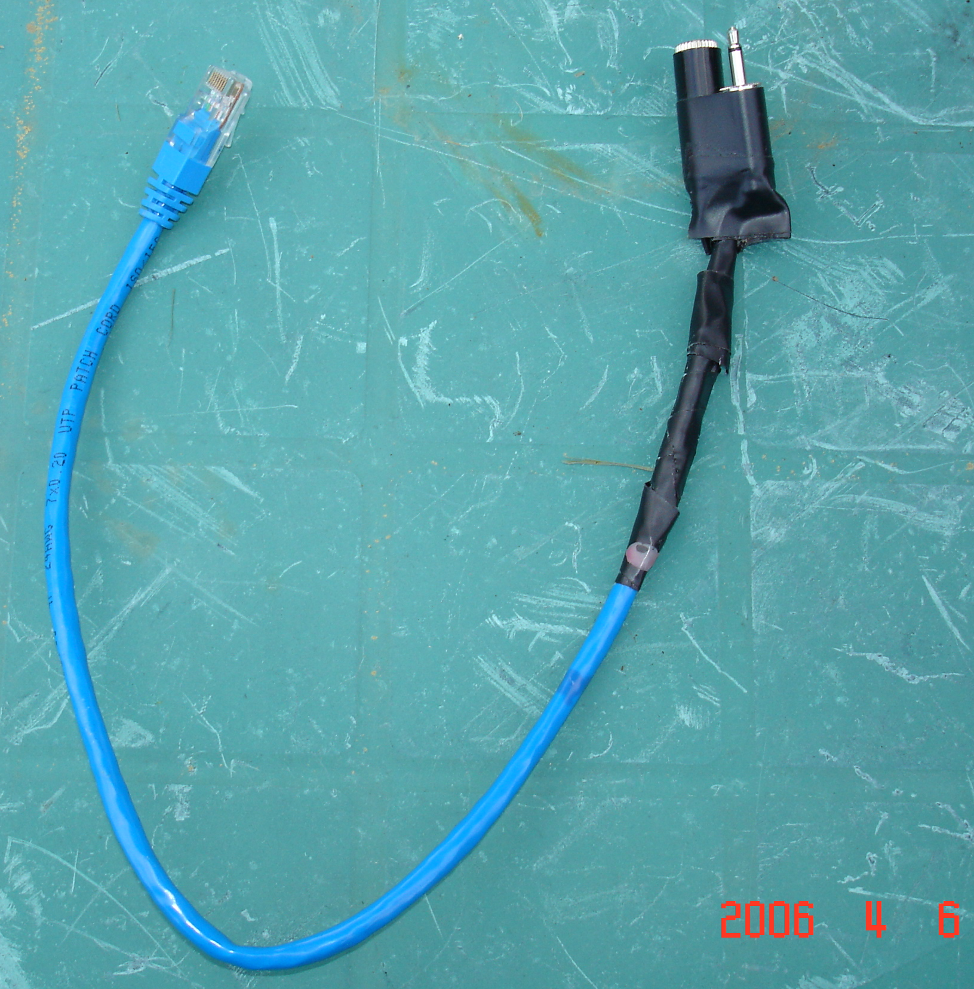
Now that all the pieces were together the ultimate test was to plug in my rather amateurish (pun intended) looking outfit and see if it worked. The Jan VHF contest was coming up and I wanted to use my headset during the contest. With everything plugged in, radio turned on, no red lights, audio out of the headphones. Now for the real test, I stepped on the switch and the red xmit light came on, I gave out with the well worn phrase," testing testing KG7P testing". The wattmeter needle jumped with my voice, not only did it work but the needle deflected as high as with the hand mike. If I had a contact with you in the Jan or June vhf contest or Tuesday evening weak signal net, you have heard this setup.

I did try the headset with my Yaesu, but I haven’t been able to get it to work. I haven’t spent much time trying to figure out what is wrong. If I get it working I’ll write a postscript to this article. In the meantime, if you try something that could be used by other Hams, let’s see it in print.

Stan KG7P

